Archery Service Center

Europees Dealer

Fairweather Fingertab

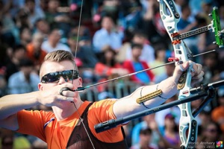
The Fairweather archery finger tab is by far the most comfortable tab I ever shot. The made by size spacer ring fits like a glove and makes your anchoring one less worry. The three sheets of kangaroo leather make for a smooth shot while protecting your fingers perfectly. The leather is also very capable of staying well in rainy conditions. I recommend you get your hands on one of these and give your archery the boost you are looking for.

Sjef van den Berg Olympics Rio 2016

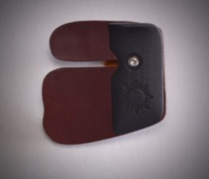
The Fairweather Finger Tab is made from light weight Urethane plastic and Urethane rubber. I don’t see any reason for the tab to be any heavier than necessary, and the urethane doesn’t get hot in the sun, or worse, cold in cold weather. It feels comfortable and natural in the hand.
The spacer/ring is available in 8 sizes starting from a small 17 mm inside diameter up to a generous 25 mm ring.
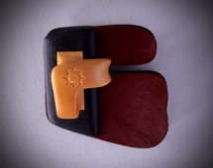
The ring is formed from a medium/soft density urethane rubber and this rubber continues to form a complete covering of the spacer
Uniquely, the Fairweather tab utilizes Kangaroo leather for both the string face and backing.
Kangaroo leather is extremely strong, but very soft. It gives excellent string feel, and allows for maximum consistency with your ‘hook’.
Kangaroo is quite unique in that the collagen fibers of the Kangaroo hide are uniformly directional, they run in parallel with the surface, and are uniform across the entire hide meaning better consistency from one piece of leather to the next.

Simon Fairweather Olympics Sydney 2000 and founder

Available at Archery Service Center February 2017

Kangaroo leather Sizes small, medium, large and large extra-long.
Urethane spacer sizes are 17, 18, 19, 20, 21, 22, 23, 24 and 25
Plate sizes small, medium and large

For more info www.archeryservicecenter.nl

