Dear Archer,
Archery Service Center has modified the production method from their “custom” bowstrings. We call it “marble bowstrings” after the reliable and solid rock. Just like marble, “marble bowstrings” has own unique look. The "vinz technique" is a good example that is developed by the archery service center. Whit more than 25 years of experience in making bowstrings, we want to give customers the same qualities as marble “reliable and solid”.

What can you expect from us ?
- Ready for use on high-performance-level.
- Reliable and solid.
- No peep rotation.
- Good prices.
- For recurve bows, compound bows, traditional bows and cross bows.
- Delivery within one week.

Examples of the Vinz technique
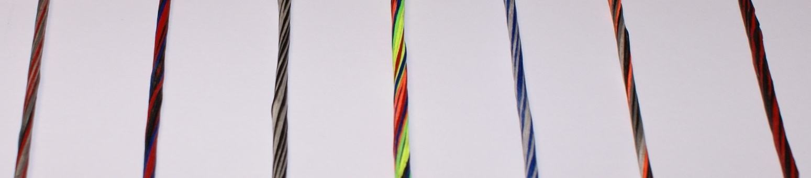

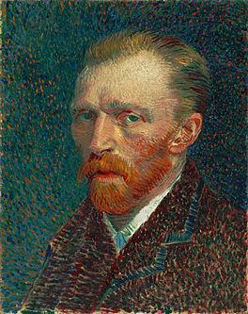
How the “Vinz” technique is created.
"Vinz" has is name from Vincent van Gogh. The Dutch painter and eccentric who lived from 1853-1890. He is considered one of the greatest painters who lived in the 19th century.
Vincent Van Gogh had a period which he with little "dashes". The canvas "sunflowers" and the self-portrait of him shown here are a good example of this technique. Those lines “dashes” are reflected in the bowstrings on the "Vinz" technique, through the use of multiple, up to seven and the rotations of the bowstring.
Archery Service Center together with marble bowstrings will take bowstrings to a new and higher level.

More techniques
Marble bowstrings have more techniques such as. The Quarto colors, tree colors, duo colors and the one color.

The duo color – on the picture 2 times two tone colors –

Notice.
The compound and crossbow bowstrings and cables are measured with twists and 100 lbs stretch. The recurve and longbow bowstrings are measured with twists and 50 lbs stretch. All "marble" bowstrings have a maximum tolerance of 0,15 %.

The experts of archery service center can place the string and cables on your bow.

For special requests please contact us at www.archeryservicecenter.nl or info@archeryservicecenter.nl

Shooting regards
Johan van Dongen

